**Front-End UI/UX Mini Project**

* **Submitted By**: 
  + *2462324 Deon Biju*  [deon.biju@btech.christuniversity.in](mailto:%20deon.biju@btech.christuniversity.in)
  + *2462357 San Antony Saji*

[san.antony@btech.christuniversity.in](mailto:san.antony@btech.christuniversity.in)

* + *2462369 Tom John Jimmy*

[tom.john@btech.christuniversity.in](mailto:tom.john@btech.christuniversity.in)

* **Course**:  *UI/UX Design Fundamentals*
* **Instructor Name**: *Mrs. Nagaveena*
* **Institution**:  *Christ University*
* **Date of Submission**: *13/08/2025*

**FITNESS TRAINER PROFILE**

**2. Abstract**

This project involves designing and developing a responsive personal fitness trainer website to showcase the services, experience, and client testimonials of Alex Johnson. The site is built using HTML and CSS, with a focus on a modern, clean, and engaging UI. The design highlights Alex’s skills in personal training, nutrition coaching, and various workout programs. Dedicated sections include a hero introduction, trainer profile, training programs, client reviews, and a contact form. The site is optimized for readability, branding consistency, and accessibility across devices.

**3. Objectives**

* Design a user-friendly interface using modern UI principles
* Develop a fully responsive layout using only HTML and CSS
* Implement structured HTML5 semantic elements
* Apply CSS styling for branding, layout, and responsive behavior
* Ensure accessibility and readability across devices

**4. Scope of the Project**

• Focused on front-end design only  
• No JavaScript or server-side functionality  
• Optimized for desktop, tablet, and mobile viewports  
• Developed using pure HTML and CSS without frameworks or libraries

**5. Tools & Technologies Used**

|  |  |
| --- | --- |
| Tool/Technology | Purpose |
| HTML5 | Markup and content structure |
| CSS3 | Styling and layout management |
| VS Code | Code editor |
| Chrome DevTools | Testing and debugging |

**6. HTML Structure Overview**

• Used semantic tags: <header>, <nav>, <section>, <footer>  
• Structured into key sections: Hero, Profile, Programs, Reviews, Contact  
• Navigation menu links for smooth page scrolling and section access

**7. CSS Styling Strategy**

• Used external CSS file (fitness.css)  
• Organized CSS with comments for easy maintenance  
• Techniques used:  
o Flexbox for layout alignment and spacing  
o Media queries for responsive design  
o CSS variables for theme color customization  
o Hover effects for buttons and navigation links  
o Mobile-first styling approach

**8. Key Features**

|  |  |
| --- | --- |
| Feature | Description |
| Responsive Design | Adapts seamlessly to all screen sizes |
| Smooth Navigation | Fixed top nav with anchor links |
| Project Cards | Flex-based layout with hover effects |
| Contact Form (non-functional) | Placeholder layout for inputs and button |
| Accessible Fonts & Colors | High contrast and readable typography |

**9. Challenges Faced & Solutions**

|  |  |
| --- | --- |
| Challenge | Solution |
| Overlapping elements on small screens | Used media queries to stack elements |
| Difficulty aligning items using float | Shifted to Flexbox and Grid |
| Typography scaling issue | Used relative units (em/rem) instead of px |

**10. Outcome**

* Created a modern, visually engaging personal fitness trainer website  
  • Achieved a fully responsive front-end design without external libraries  
  • Strengthened skills in semantic HTML, CSS variables, and responsive layouts  
  • Implemented a clear UI hierarchy to enhance user experience

**11. Future Enhancements**

Add JavaScript for animations and interactive elements  
• Enable functional contact form with backend integration  
• Include a blog section for fitness tips and updates  
• Add a theme toggle (light/dark mode) for customization

**12. Sample Code**

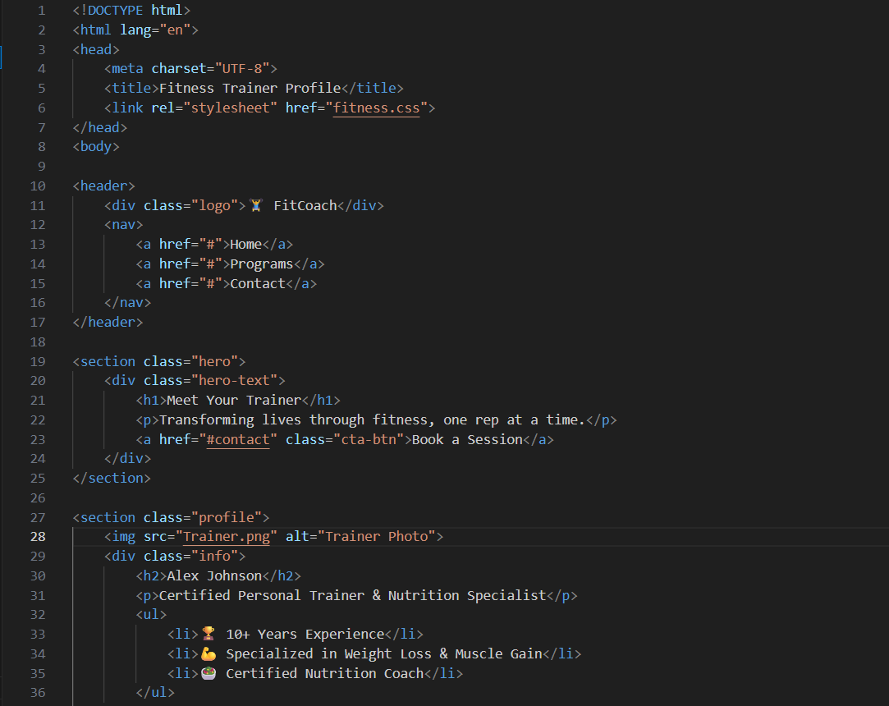

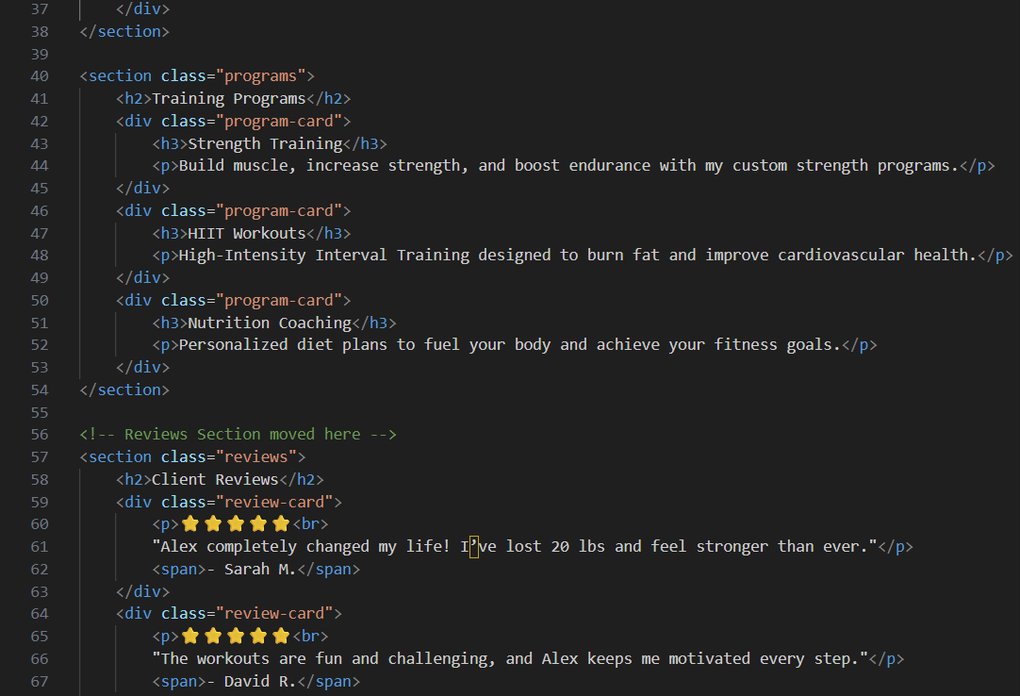

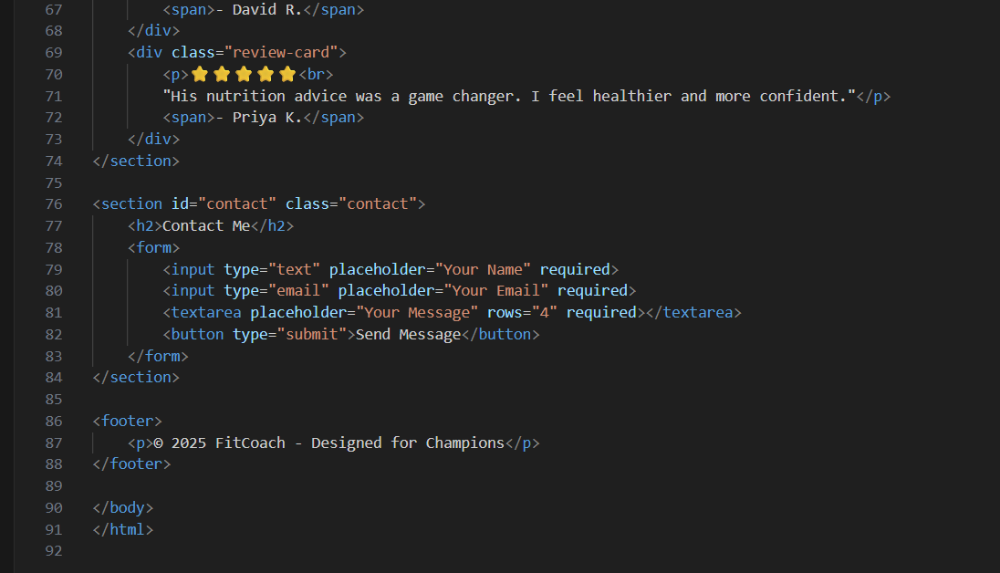

**13. Screenshots of Final Output**

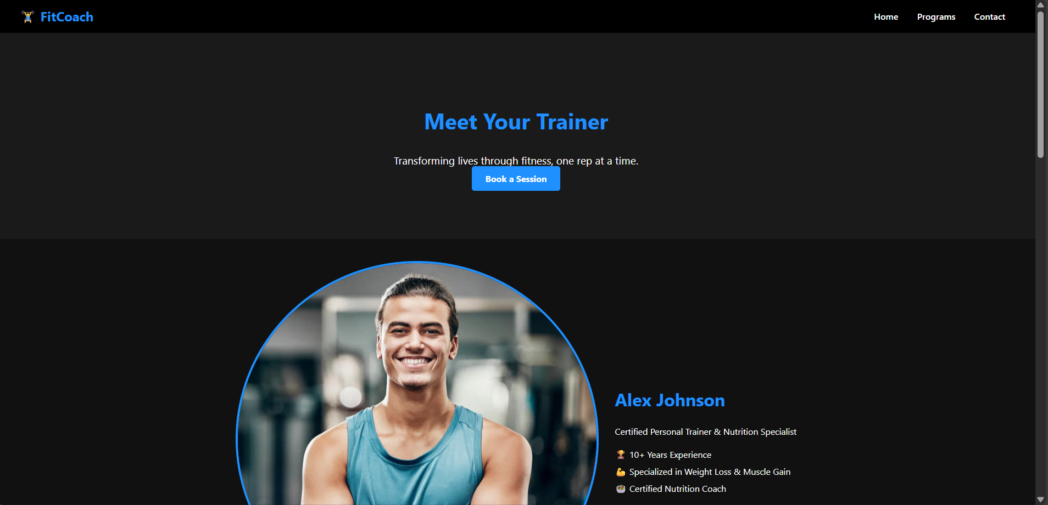

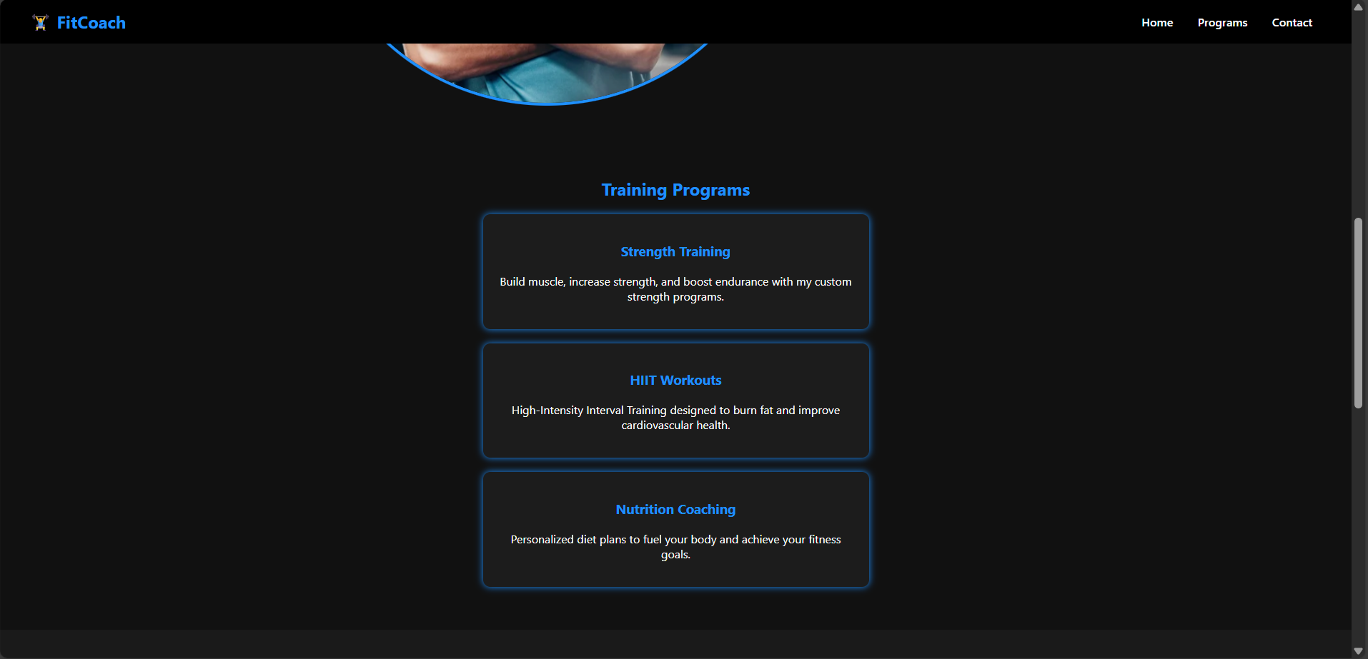

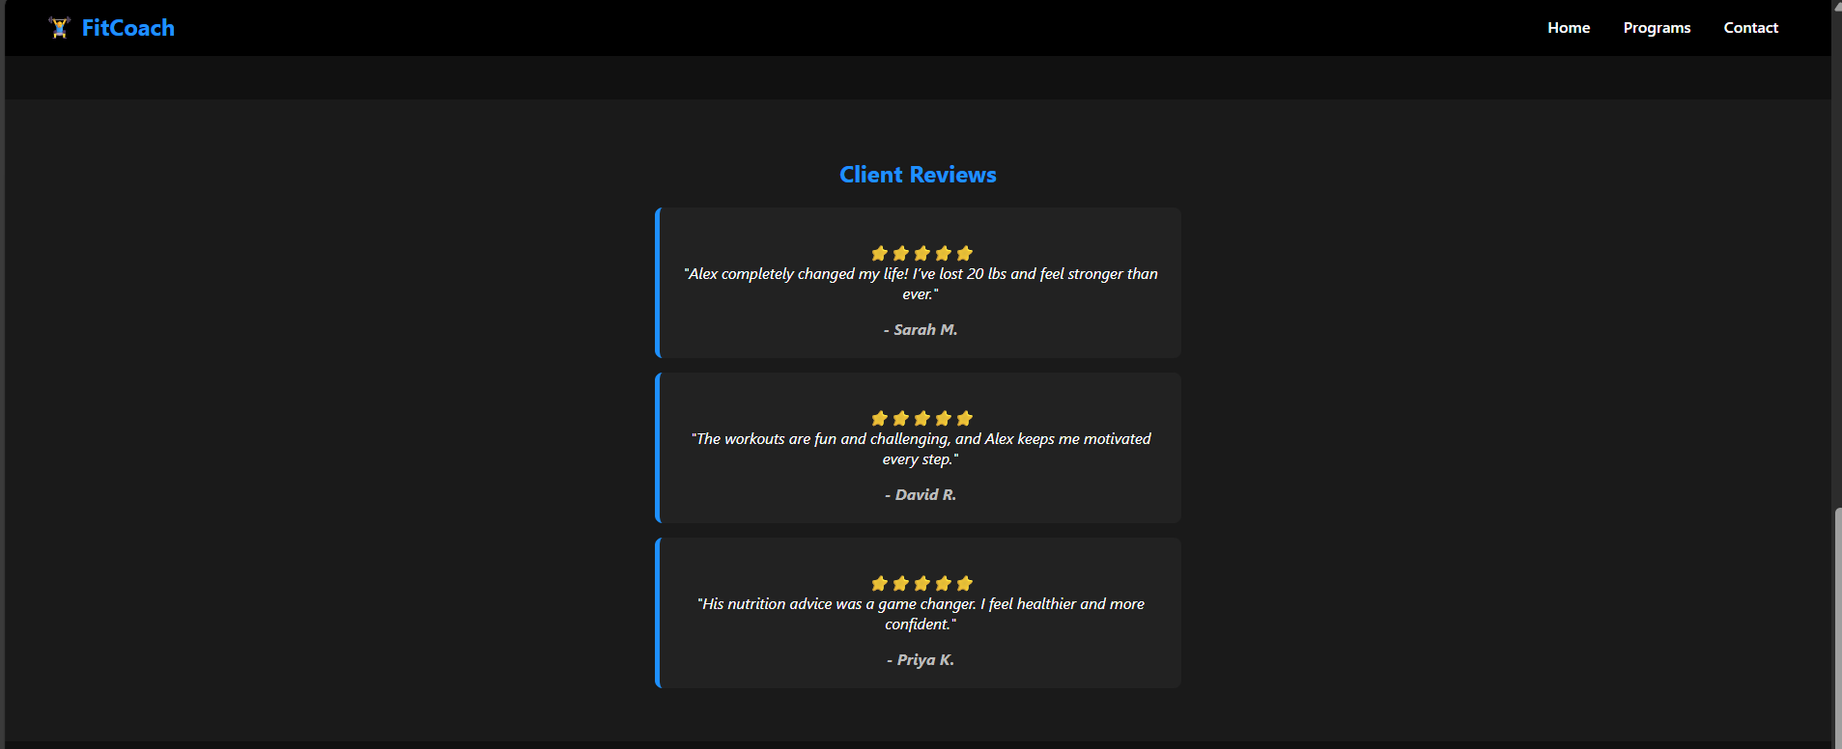



**11. Conclusion**

The development of the personal portfolio website successfully demonstrated the application of HTML and CSS in building a visually appealing, responsive, and user-friendly platform to showcase skills, projects, and achievements. This project strengthened our understanding of semantic HTML, CSS styling strategies, and responsive layouts. Through hands-on practice, we refined our ability to structure content effectively, maintain consistent branding, and create an engaging user experience. Overall, the project enhanced both technical skills and design thinking in front-end web development.

**12. References**

* L&T LMS : <https://learn.lntedutech.com/Landing/MyCourse>